Problem 1: Decision tree performance at different depths

Depth | Precision | Recall | F1-Score
1 | 0.483333 | 0.666667 | 0.540230
2 | 0.972222 | 0.962963 | 0.965899
3 | 1.000000 | 1.000000 | 1.000000
4 | 1.000000 | 1.000000 | 1.000000
5 | 1.000000 | 1.000000 | 1.000000

- The depth of the highest Recall
At depths 3, 4, and 5, Recall reaches 1.0000, which means that all positive examples (true category 1) are correctly classified.
Depth 2 has a recall of 0.9629, which means that some positives have been misclassified.
Conclusion: Starting max_depth=3, the model is already able to fully distinguish between categories without increasing depth.
- Depth corresponding to minimum precision
At a depth of 1, Precision 0.4833 is the lowest, indicating a high percentage of false positives (many negatives are misclassified as positive).
As the depth increases, the Precision gradually increases, reaching 1.0000 at depth=3.
Conclusion: When the depth is too small (max_depth=1), the model has poor classification ability for negative cases.
- Depth with the highest F1 score
depth=3 and above, with an F1 Score of 1.0000, indicates that the model has achieved the best balance between Precision and Recall.
Optimal depth: max_depth=3 because:
depth=3 has reached the perfect classification, and increasing the depth further will not improve performance.
Trees that are too deep may lead to overfitting, reducing generalization ability.
Micro Method
Calculation:
TP (True Case), FP (False Positive), FN (False Negative) for all categories are added together, and Precision, Recall, and F1 scores are calculated based on the total.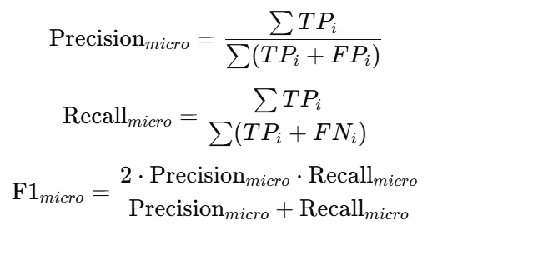 Applicable Scenarios:
Ideal for balanced category distribution or when overall classification performance is a concern.
Advantages: Considering the overall classification situation, it is suitable for scenarios with a large number of categories.
Disadvantage: The effect of small categories can be masked when the categories are unevenly distributed.

Macro Averaging
Calculation:
Precision, recall, and F1 scores were calculated separately for each category, and then averaged across all categories.
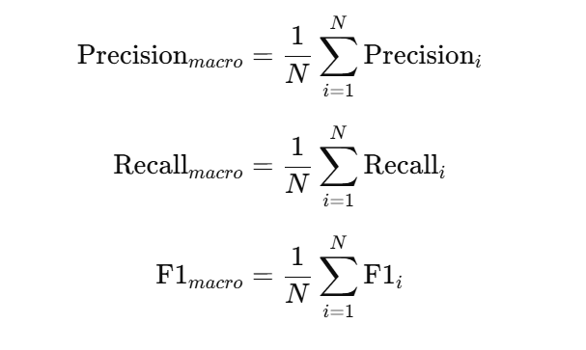
Applicable Scenarios:
Useful for focusing on the classification performance of each category, especially when the category distribution is uneven.

Advantages: Focus on the individual performance of each category and not be dominated by the majority.
Disadvantage: Overall performance may be underestimated when the number of categories is unbalanced.

Weighted Averaging
Calculation:
Precision, recall, and F1 scores were calculated separately for each category, and then weighted averaged based on the number of samples in the test set for each category.
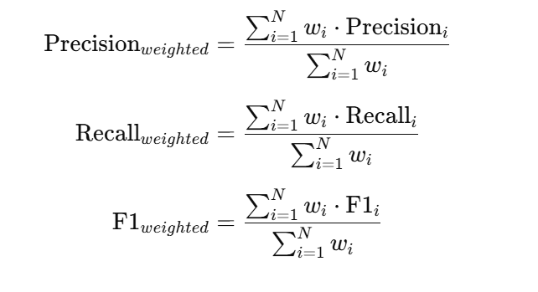
Applicable Scenarios:
It is suitable for situations where the distribution of categories is uneven, and can reflect the impact of the proportion of categories in the data.

Advantages: Considers category imbalances and reflects overall classification performance.
Disadvantages: It may be dominated by categories with large amounts of data, resulting in the performance of small categories being neglected.

Problem 2: The first split in the decision tree
Selected features
First split characteristic: Uniformity_of_Cell_Size
Splitting threshold: 3.5
Index | total | left | right | weighted
Entropy | 0.9165 | 0.3203 | 0.3014 | 0.3145
Gini | 0.4432 | 0.1096 | 0.1014 | 0.1071
Misclassification Error | 0.3315 | 0.0582 | 0.0536 | -
Info Gain | 0.6020 | - | - | -

Problem 3: PCA impact analysis
Model 1: Using Only the First Principal Component
Confusion Matrix:
[[37 6]
[ 0 71]]
False Positives (FP): 6
True Positives (TP): 71
False Positive Rate (FPR): 0.1395
True Positive Rate (TPR): 1.0000
Model 2: Using Both Principal Components
Confusion Matrix:
[[37 6]
[ 0 71]]
False Positives (FP): 6
True Positives (TP): 71
False Positive Rate (FPR): 0.1395
True Positive Rate (TPR): 1.0000
For the continuous Breast Cancer dataset, using PCA-reduced data (even just the first principal component) was as effective as using the original continuous data, indicating that PCA did not negatively impact the model's performance in this case.

